**Module-4**

**1.What are the main factors that can affect PPC bidding?**

Pay-per-click (PPC) bidding is the process of placing bids on specific keywords or phrases in order to display ads on search engine results pages (SERPs) or other advertising platforms. The cost of PPC advertising can be influenced by a variety of factors, including:

1. Keyword competition: The level of competition for a particular keyword can affect the cost of bidding on that keyword. Highly competitive keywords are likely to be more expensive than less competitive ones.

2. Ad placement: The position of your ad on the search engine results page can impact the cost of bidding. Ads that appear at the top of the page typically cost more than those that appear lower down.

3. Ad relevance: The relevance of your ad to the search query can affect the cost of bidding. Ads that are highly relevant to the user's search are more likely to be clicked, and therefore may cost more.

4. Quality score: The quality of your ad and landing page can impact your quality score, which in turn can affect the cost of bidding. Ads with high-quality scores are likely to have lower costs per click.

5. Target audience: The demographics and geographic location of your target audience can impact the cost of bidding. For example, targeting a highly specific demographic or location may cost more than targeting a broader audience.

6. Bidding strategy: The bidding strategy you use can also impact the cost of bidding. For example, using a manual bidding strategy may allow you to have more control over your costs, while using an automated bidding strategy may help you to achieve better results more efficiently.

7. Ad format: The format of your ad can affect the cost of bidding. Some ad formats, such as video or interactive ads, may be more expensive than others, such as text or image ads.

It is important to consider these factors when developing a PPC bidding strategy in order to achieve the best possible results within your budget.

**2. How does a search engine calculate actual CPC?**

The actual cost per click (CPC) in a search engine advertising campaign is the amount that an advertiser pays each time a user clicks on their ad. The actual CPC is determined by a real-time auction process that takes place every time a user searches for a keyword or phrase that is targeted by an advertiser's campaign. Here's how the auction process works:

1. User searches for a keyword: When a user enters a keyword or phrase into the search engine, the search engine examines the advertiser's keywords to determine if there is a match.

2. Advertisers submit bids: Advertisers who have targeted that keyword are entered into an auction, and each advertiser submits a bid for how much they are willing to pay for each click on their ad.

3. Ad relevance and quality: The search engine algorithm considers the relevance and quality of each ad to the user's search query, as well as other factors like historical performance and user experience.

4. Winning ad is chosen: Based on the combination of bid amount and ad relevance/quality, the search engine selects the winning ad and determines the actual CPC that the advertiser will pay.

The actual CPC that the advertiser pays may be lower than their maximum bid, as they only pay the amount necessary to beat the second-highest bid and secure the ad placement. Additionally, the actual CPC may vary depending on the performance of the ad, as search engines may offer discounts for ads with high click-through rates or penalize ads with low relevance or poor user experience.

**3.What is a quality score and why it is important for Ads?**

A quality score is a metric used in search engine advertising (such as Google Ads) to measure the quality and relevance of an ad and its corresponding landing page to the keywords it targets. Quality score is a key factor in determining ad placement and cost per click (CPC) in search engine advertising campaigns.

Quality score is important because it affects the ad rank, or the position in which an ad appears on the search engine results page (SERP), as well as the cost per click that an advertiser pays for each click on their ad. Higher quality scores typically result in better ad positions and lower CPCs, while lower quality scores can result in lower ad positions and higher CPCs.

The factors that influence quality score include:

1. Ad relevance: The degree to which the ad matches the user's search query.

2. Landing page experience: The quality and relevance of the landing page that the user is directed to after clicking on the ad.

3. Expected click-through rate (CTR): The likelihood that the ad will be clicked based on past performance.

4. Ad format: The format of the ad and how it appears on the SERP.

Improving quality score can help advertisers achieve better ad positions and lower CPCs, resulting in a better return on investment (ROI) for their advertising spend. This can be achieved by creating relevant and compelling ad copy, using targeted keywords, and providing a high-quality landing page experience for users.

**4.Create an ad for your website/ blog in Google Ads that display on the display network with the properly targeted audience.**

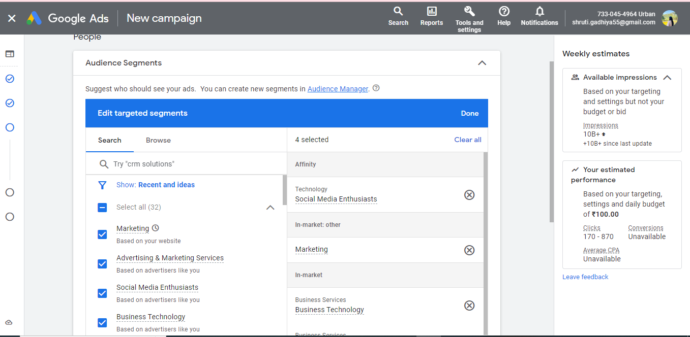

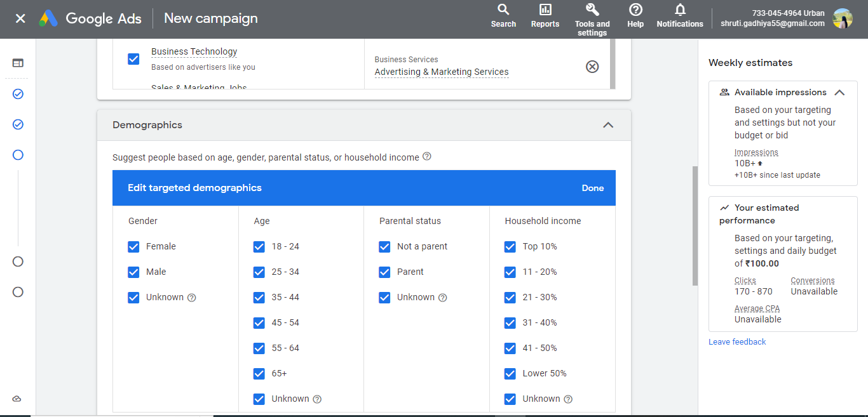

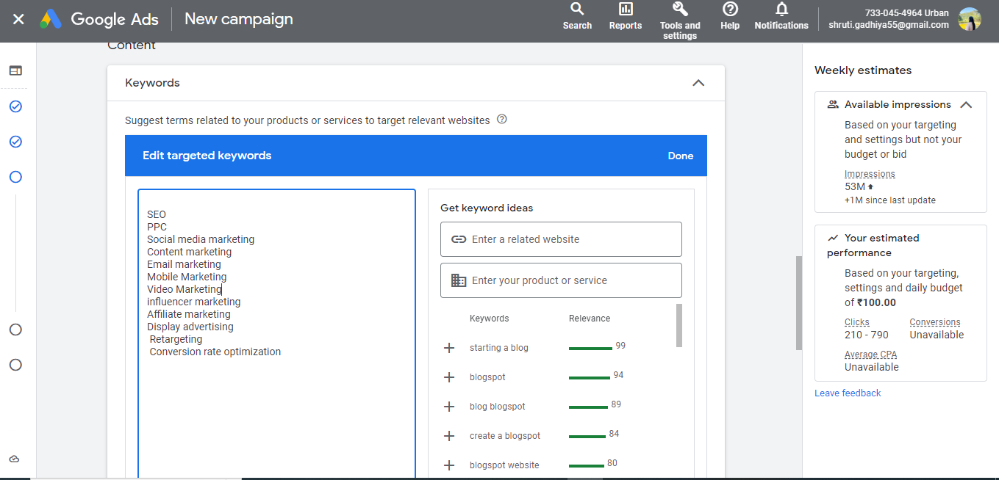

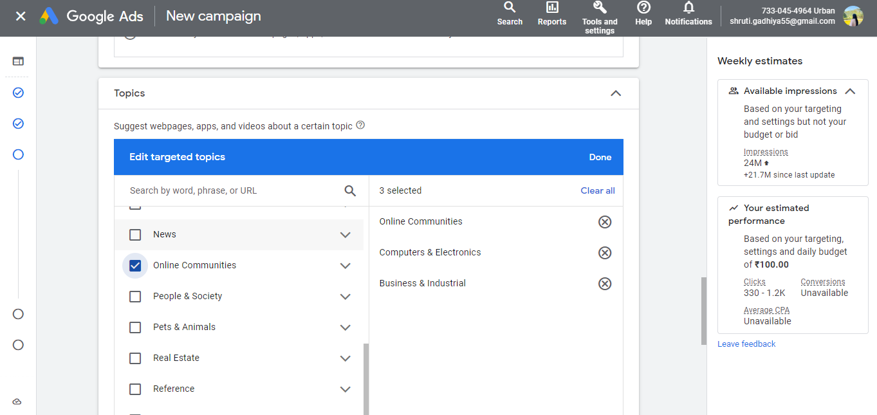

**5. Create an ad for http://esellerhub.com/ to get the maximum Clicks.**

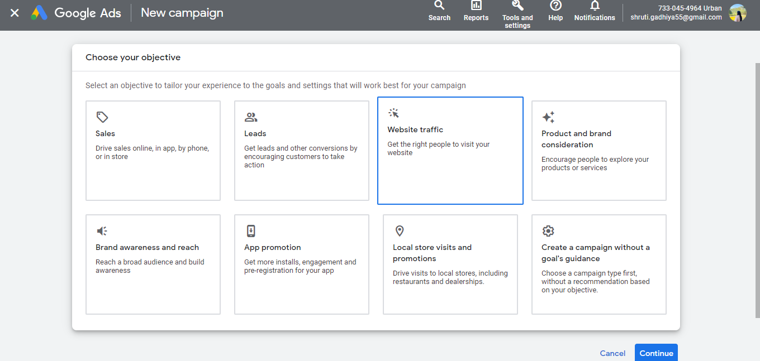

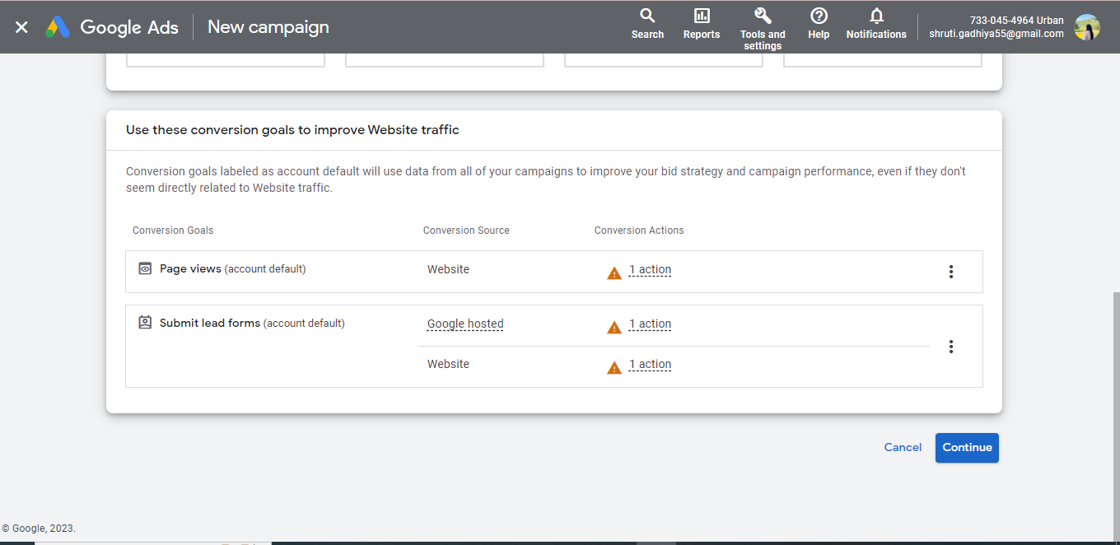

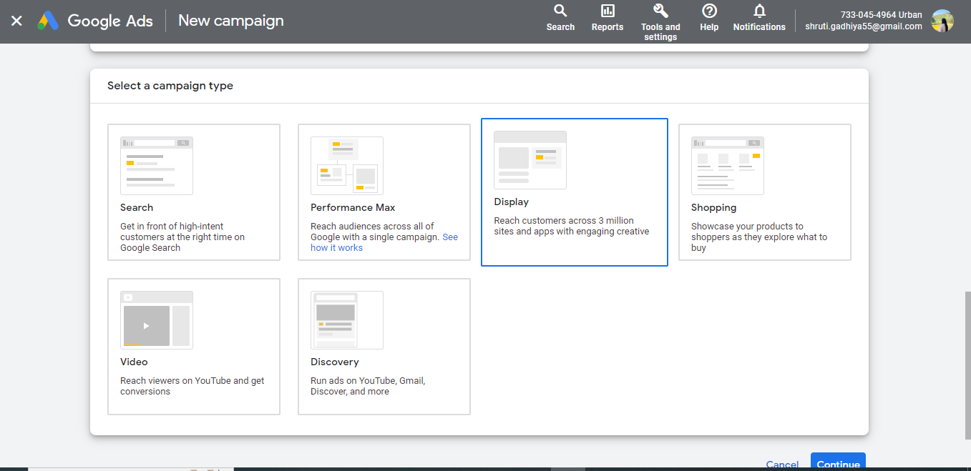

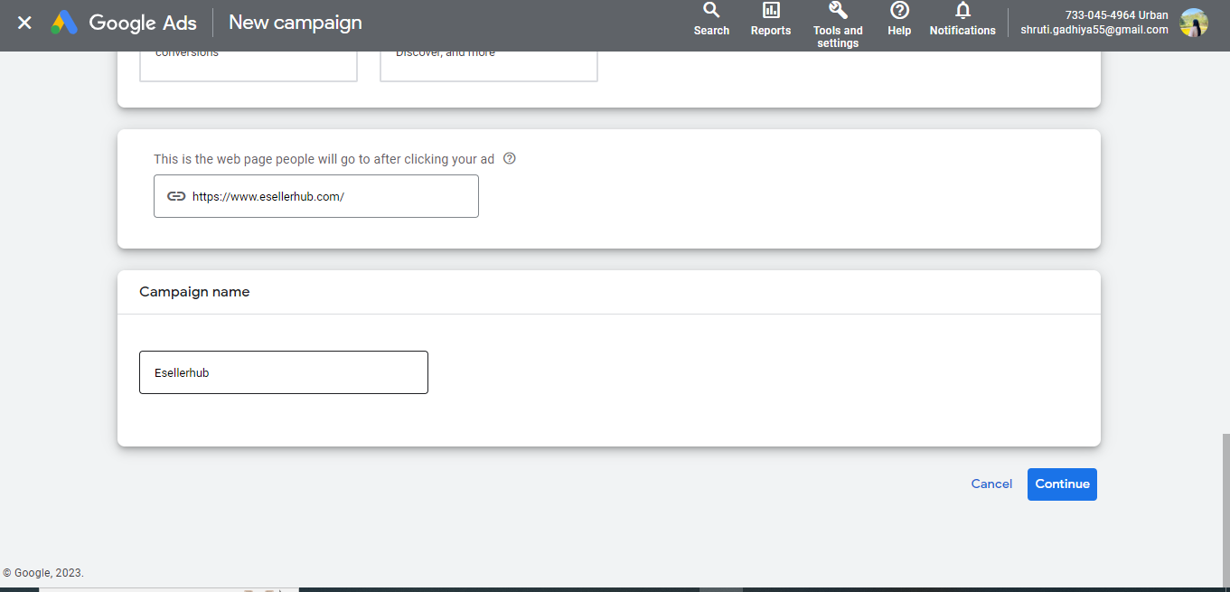

**6. Create an ad for http://www.designer2developer.com**

* **Create an ad for the display network.**
* **Choose a proper Target audience.**
* **Expected conversion: need maximum user engagement within the budget.**
* **Budget 5000**

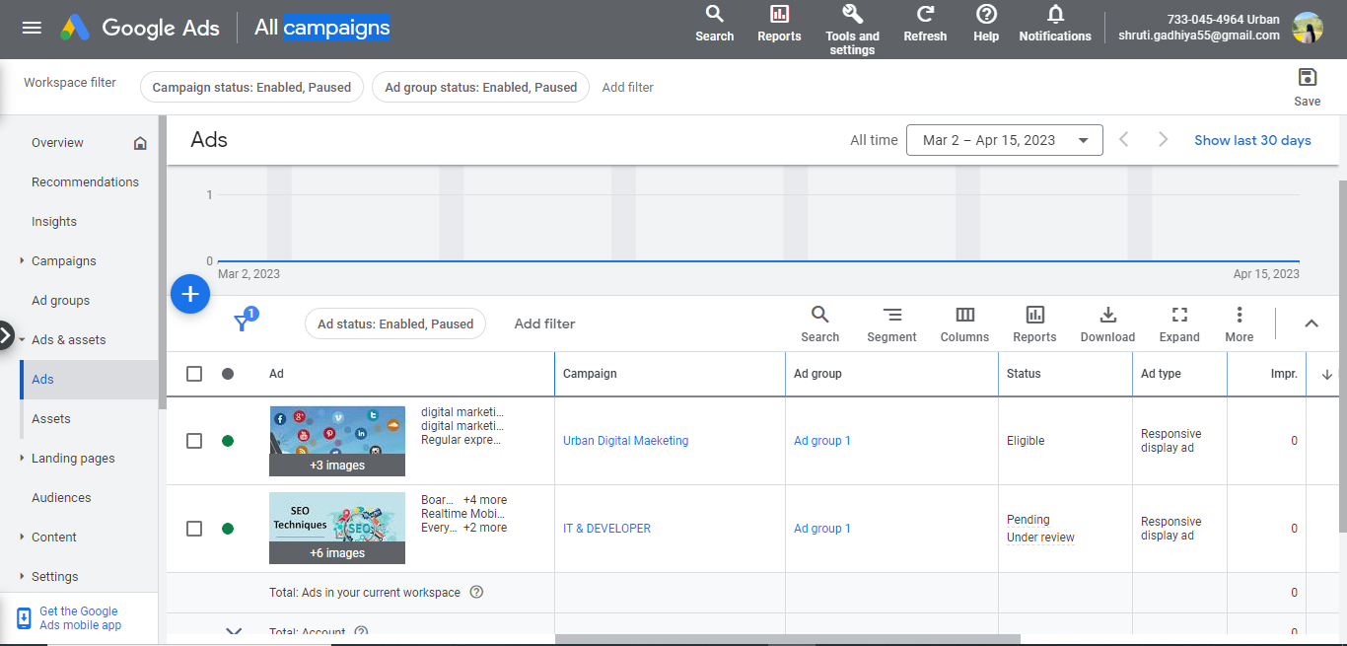

**LINK:-**

[**https://ads.google.com/aw_cm/ExternalPreview?hl=en_US&ad=655187337586&adGroup=143330328850&ocid=1195635311&isObfuscatedOcid=false&showMulPreview=true&showVariations=true&creativeType=35&pk=ACMAqCfOCRBTdZaZvQchNxT8j6PWHM_KlzqifQKjV-3LwukY71LDyBvcSzWvqbCqTM2UPZgfJkbPB5aB7Tth57NMJlpMHOb5Ru_31fmMCeBintDYp5kV22tAMJmSISOHkUXFS3Cf90bxAZe3AR0s6-WjsrihpzoLBJYNnmcjs41Cnu45bfuXsdtpUsw**](https://ads.google.com/aw_cm/ExternalPreview?hl=en_US&ad=655187337586&adGroup=143330328850&ocid=1195635311&isObfuscatedOcid=false&showMulPreview=true&showVariations=true&creativeType=35&pk=ACMAqCfOCRBTdZaZvQchNxT8j6PWHM_KlzqifQKjV-3LwukY71LDyBvcSzWvqbCqTM2UPZgfJkbPB5aB7Tth57NMJlpMHOb5Ru_31fmMCeBintDYp5kV22tAMJmSISOHkUXFS3Cf90bxAZe3AR0s6-WjsrihpzoLBJYNnmcjs41Cnu45bfuXsdtpUsw)

